C02 ASSESSMENT TOOL-1
CSA1305 -TOC
K Gayathri (192311448)

1.Aim
To design a Deterministic Finite Automaton (DFA) over Σ = {0,1} that accepts all binary strings ending with "01", minimize the DFA, and explain its real-world applications.

Theory
In many security systems such as ATM machines, embedded security devices, login authentication systems, and smart cards, passwords must satisfy specific patterns.
A DFA is used because it:
- Processes one character at a time.
- Requires only one scan.
- Produces deterministic results.
- Is fast and memory efficient.
Here the password is accepted only if the last two bits are "01".

Language
$$L=\left\{w∈{\left\{0 , 1\right\}}^{*}∣w\text{ ends with }01\right\}$$
Examples accepted:
- 01
- 101
- 0001
- 1101
Examples rejected:
- 10
- 11
- 00
- 1110

DFA
States
- q0 → Start state
- q1 → Last symbol is 0
- q2 → Last two symbols are 01 (Accept)

Transition Table
Current State | Input 0 | Input 1
→ q0 | q1 | q0
q1 | q1 | q2
*q2 | q1 | q0

Automata Diagram
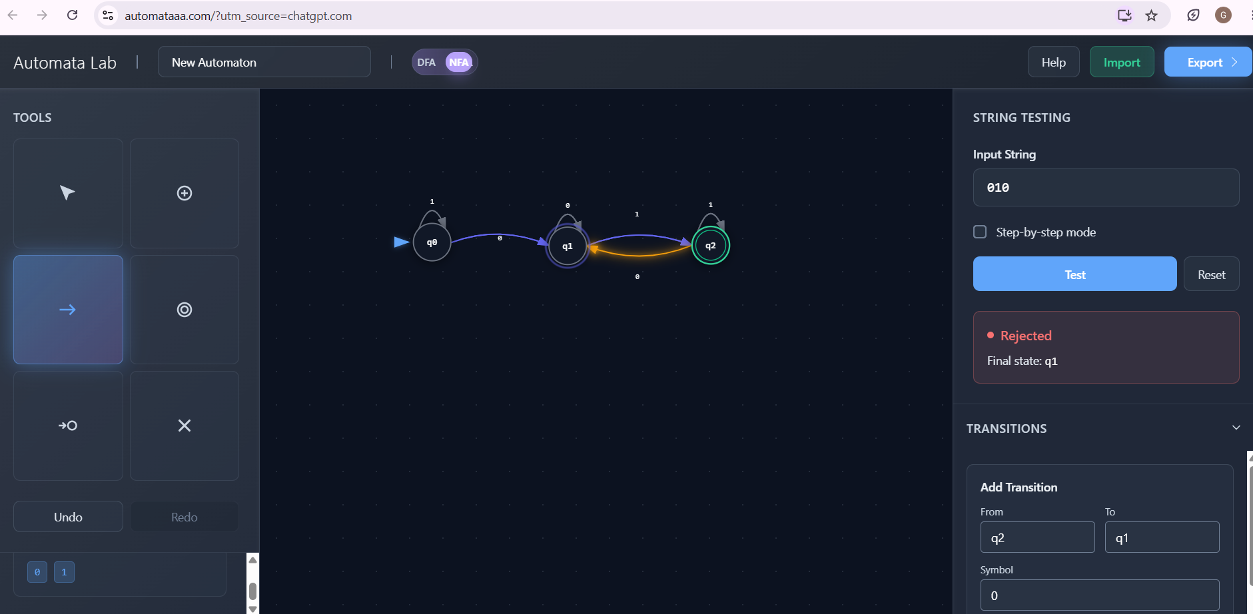
Minimization
The DFA already has only 3 states.
No two states are equivalent.
Therefore,
Minimum DFA = Original DFA
Number of states before minimization = 3
Number after minimization = 3

Real-world Applications
- ATM PIN verification
- Password authentication
- Embedded security controllers
- Digital lock systems
- Smart cards
- IoT authentication

Advantages of Minimized DFA
- Less hardware memory
- Faster processing
- Reduced circuit complexity
- Lower power consumption
- High-speed password validation
Conclusion
A minimized DFA validates passwords ending with "01" efficiently, making it ideal for authentication systems and embedded hardware.
Regular Expression for "aaaabb"
2.Aim
To design a regular expression for the string aaaabb and explain how regular expressions validate user input.

Theory
A Regular Expression (RE) is a sequence of symbols used to describe patterns.
Web applications use regular expressions to check whether user input follows the required format.
Examples:
- Email validation
- Mobile number validation
- Password rules
- ZIP codes
- Usernames

Regular Expression
Since only one string is accepted,
aaaabb
or mathematically
$$R=aaaabb$$

Language
$$L=\left\{aaaabb\right\}$$

Working
Input:
aaaabb
Accepted
Input:
aaabb
Rejected
Input:
aaaabbb
Rejected

Applications in Web Development
Regular expressions validate:
- Email addresses
- Passwords
- Phone numbers
- Usernames
- PIN numbers
- Postal codes
- Credit card formats

Advantages
- Fast validation
- Reduces server load
- Prevents invalid input
- Improves security
- Easy implementation

Role of Regular Languages
Regular languages are recognized using finite automata.
Therefore,
Regular Expression
↓
Finite Automaton
↓
Input Validation
This allows web applications to validate millions of requests efficiently.
Conclusion
Regular expressions provide an efficient method for validating user inputs while improving application performance and security.

3. Convert ab into Finite Automaton
Aim
To convert the regular expression
$$a^{*}b^{*}$$
into an equivalent finite automaton and explain their equivalence.

Theory
The expression
$$a^{*}b^{*}$$
means
- Zero or more a's
- Followed by zero or more b's
No a can appear after a b.

Examples
Accepted
ε
a
aa
bbb
aaabbb
ab
Rejected
aba
ba
baba
abba
DFA
States
- q0 → reading a's
- q1 → reading b's
- q2 → dead state
Transition Table
State | a | b
→*q0 | q0 | q1
*q1 | q2 | q1
q2 | q2 | q2

DFA Diagram
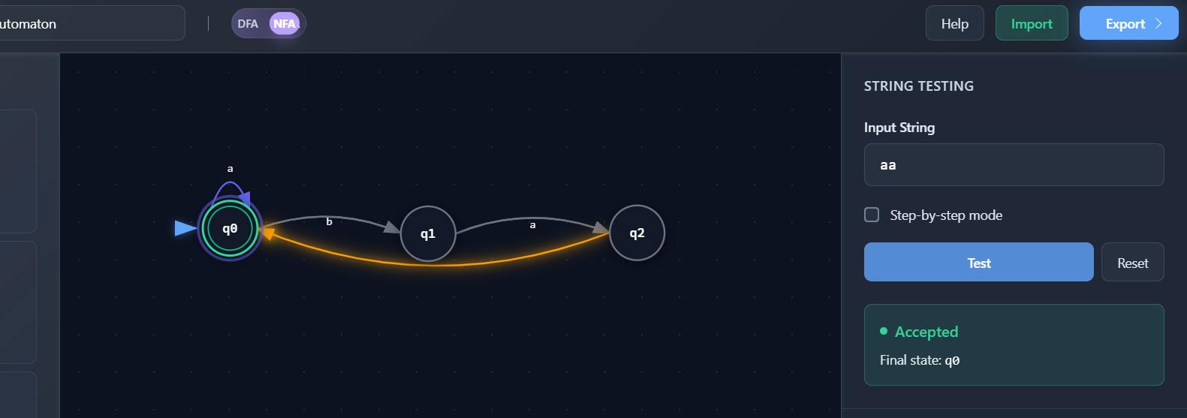
Why RE and FA are Equivalent
Every Regular Expression can be converted into
- NFA
- DFA
Every DFA can be converted back into
- Regular Expression
Hence,
Regular Expression ⇄ Finite Automaton
Both recognize exactly the Regular Languages.
Applications
- Compiler lexical analysis
- Intrusion detection
- Log monitoring
- Packet filtering
- Search engines
- Spam filtering

Advantages
- Linear-time processing
- Efficient pattern matching
- Low memory usage
- Easy hardware implementation

Conclusion
Regular expressions and finite automata are mathematically equivalent and are widely used for real-time pattern recognition.
4. Pumping Lemma for L = {aⁿbⁿ}
Aim
To prove that
$$L=\left\{a^{n}b^{n}∣n≥0\right\}$$
is not regular using the Pumping Lemma.

Pumping Lemma
If a language is regular,
then every sufficiently long string
$$w=xyz$$
must satisfy

$$∣xy∣≤p$$

$$∣y∣>0$$

$$xy^{i}z∈L$$
for every
$$i≥0$$

Proof
Choose
$$w=a^{p}b^{p}$$
where
p = Pumping length
Since
$$∣xy∣≤p$$
both x and y contain only a's.
Let
$$y=a^{k}$$
where
k>0
Now pump
$$i=2$$
New string
$$xy^{2}z=a^{p+k}b^{p}$$
Now,
Number of a's ≠ Number of b's
Therefore,
$$xy^{2}z∉L$$
This contradicts the Pumping Lemma.
Hence,
$$L=\left\{a^{n}b^{n}\right\}$$
is Not Regular.

Why Finite Automata Fail
Finite automata have finite memory.
They cannot count equal numbers of
- a's
- b's
Hence they cannot recognize
$$a^{n}b^{n}$$

Implications in Compiler Design
Programming languages contain nested structures such as:
if
{
while
{
}
}
Examples:
- Matching parentheses
- Nested loops
- Function calls
- Balanced braces
- XML tags
Finite automata cannot process these.
Compilers therefore use:
- Pushdown Automata (PDA)
- Context-Free Grammars (CFG)
- Stack-based parsing
Conclusion
The Pumping Lemma proves that $L=\left\{a^{n}b^{n}\right\}$is not regular, showing why compilers require more powerful models than finite automata.
5. Closure Properties of Regular Languages
Aim
To explain how closure properties allow multiple pattern-matching rules to be combined while preserving regularity.
Theory
Regular languages remain regular after applying operations called closure properties.
This makes them ideal for combining multiple detection rules.
Closure Operations
1. Union ( ∪ )
Accepts strings from either language.
Example
Spam OR Malware
2. Concatenation ( · )
Combines two patterns sequentially.
Example
Login + OTP
3. Kleene Star ( * )
Repeats a pattern zero or more times.
Example
aaaa...
4. Intersection ( ∩ )
Accepts strings common to both languages.
Used in security filters.
5. Complement
Accepts all strings not in the language.
Useful for blocking malicious inputs.
6. Difference
Accepts strings in one language but not another.
Used to remove false positives.
Why the Result Remains Regular
Each closure operation can be implemented by constructing another finite automaton.
Therefore,
Regular Language
+
Closure Operation
↓
Another Regular Language
Thus, the resulting language is still recognized efficiently by a DFA or NFA.
Applications
Intrusion Detection
Combine signatures for multiple attack patterns.
Spam Filtering
Detect spam keywords using union and concatenation.
Input Validation
Combine rules for usernames, passwords, and email formats.
Firewalls
Match multiple packet filtering rules.
Lexical Analysis
Recognize identifiers, keywords, operators, and literals together.
Advantages
- Fast execution
- Easy DFA implementation
- Efficient memory usage
- Supports multiple rules
- Scalable for large systems
- Reliable pattern matching
Conclusion
Closure properties enable multiple regular-language patterns to be combined without losing regularity. This guarantees that the combined language can still be recognized efficiently using finite automata, making regular languages highly suitable for applications such as intrusion detection, spam filtering, input validation, and compiler lexical analysis

